
COMHALTAS CEOLTÓIRI ÉIREANN
Burke-Curry-Seery Branch

From the Chairman,

This is the 5th newsletter this year (November 2005 to October 2006).

Our latest news is staring you right in the face - the new name of the Branch. Utilizing a paper ballot in June, members voted to change the name of our Branch to Burke-Curry-Seery Branch. This name change honors the late Eddie Burke who brought much to Connecticut and Western Massachusetts through his fiddle playing and active participation in Comhaltas Ceoltóiri Éireann.

At last count, we have 164 members which is a very encouraging sign. It is, I believe, evidence that our Branch of Comhaltas is alive and well. However exciting it is to report that the membership numbers are up, I think it is essential that we continue to work to bring Irish culture to the attention of the many people in the area who claim Irish heritage or who have an interest or love in Irish music, dance, song and language.

This summer the Branch is focusing its efforts on two important issues. Firstly, our plan to have a presence at the New Haven and Glastonbury festivals was executed thanks to the volunteers who stepped forward to help. Our next effort will be to staff a Comhaltas table at the Danbury festival in September. If you can help out, please give me a call. Next year we should also get to the Fairfield festival

to continue spreading the word about what CCE is and what it offers.

Secondly, we are sponsoring the Echoes of Erin Concert Tour on October 13, 2006 at Hamden High School, Dixwell Avenue, in Hamden, CT. We are asking each member to help spread the word in order to sell tickets and there are ample volunteer opportunities available. For more information, see below.

The next meeting of the Branch is September 17, 2006 in Glastonbury, CT where we will accept nominations for Branch officers. Elections will occur at the Annual General Meeting on October 29, 2006 in Glastonbury, CT. At this meeting, members vote for officers of the Board for the following year (November 1 to October 31). If you are interested in a position on the Board, I encourage you to seek an office. The outgoing Board members are more than happy to meet with anyone interested to talk about the commitment required to take on a Board officer role.

Also, please read on for important information pertaining to planned Comhaltas activities. As always, your input is most welcome. Go raibh maith agat. (Thank you)

Terry Sullivan, Cathaoirleach (Chairman)

Echoes of Erin Concert - October 13, 2006

The Burke-Curry-Seery Branch of CCE is sponsoring the 2006 Echoes of Erin Concert on Friday, October 13, 2006 at Hamden High School at 7:30 p.m. This show features talented singers, dancers and musicians who are traveling the United States this fall. Tickets cost only $20 for adults and $10 for children age 14 and under. We are hoping to sell as many advance tickets as possible so contact us soon to obtain your seats. We are asking for volunteers to host some of the performers (mostly teenagers and young adults) which mean transporting them to the concert venue on Friday evening and providing them a place to sleep for the night. More information will be provided in the weeks to come. Tell your friends and neighbors. If you have any questions, please call Terry Sullivan at (860) 584-8776, John O'Donovan at (203) 281-3563 or Jill Morrison at (860) 830-2699. Enclosed are two flyers advertising the show. We are asking you to help to get the word out by posting these flyers in your area libraries, clubs, stores, etc.

Next Branch Meeting - September 17th

The next meeting of the Burke-Curry-Seery Branch of CCE will be held at 2:00 p.m. on Sunday, September 17, 2006 at the Irish American Home Society, Commerce Street, Glastonbury, CT. Immediately following the meeting, enjoy a traditional Irish music seisiun led by CCE member Tom Walsh from 4:00 p.m. to 6:00 p.m.

Nominations for CCE Officers

It's never too late to think ahead. The "year" for the present Branch Board members expires on October 31, 2006. If you are interested in serving on the Board for a one-year term, please submit your name to the nominating committee by October 1, 2006. The nominating committee consists of Greg Gregonis (860-763-6754 or email grouse01@cox.net), Eileen Grabowski (860-529-2922), and Terry Sullivan (860-584-8776 or email terrysullivan-1@hotmail.com). If you have particular questions about the duties and time commitments involved, please feel free to contact any of the present Board members.

Advertisers Wanted

We are accepting advertisements to help defray costs of printing and mailing our newsletter. Printing 200 newsletters costs about $85 and mailing labels, stamps, etc. costs another $90. That's $175 for each mailing. By selling ads on the last page, we can greatly reduce these costs. If you or someone you know would like to advertise in our newsletter please contact the Branch at curry-seery-cce@hotmail.com and ask about rate and publication information.

Danbury Irish Festival in September

The Greater Danbury Irish Festival will be held in Danbury, CT on September 8, 9 and 10. This weekend festival is held in a beautiful New England setting at the Charles Ives Center on the campus of Western Connecticut State University, Mill Plain Road, Danbury, CT.

There will be Set Dancing Lessons conducted on Friday, September 8, starting at 7:30 p.m. in the Cultural Tent. Gini McCauley is the Instructor. On Saturday, September

9, there will be a Ceili from 6:00 - 10:00 p.m. with music by "The Green Gates Ceili Band". For information contact Gini McCauley, 203-748-0055. Also featured will be step dancing, language workshops, Irish bands, and bagpipes, and also Cultural Exhibits, Shopping, Traditional foods and great craic! The Festival is a tribute to Irish culture and heritage and you should mark it on your calendar now! Stop by the CCE table too. Check out the festival's website at: www.danburyhibernians.org for more information.

Lá na Gaeilge – A Day of Irish Language

The Irish Language class (Cairde na Gaeilge) at the New Haven Irish American Community Center would like to invite all who are interested in learning and using the Irish language to a one-day Irish language immersion course. The day is filled with Irish classes, seisiún and workshops for dancing and music and will be a great way of learning and speaking Irish in a fun and friendly atomosphere. There will be classes for each level of ability – beginners (no Irish), intermediate and advanced, so whatever your level, please come and join us! Saturday, September 30th, 8:30 a.m. to 5:00 p.m.

The cost for the day, including classes, workshops, refreshments and lunch is $45 for early registration ($55 after Sept. 8th). For further information contact Pam Murray at (203) 488-3866 or Johannah Mackey at (860) 346-9224. The website is www.iacc-ct.com.

Some Phrases, their pronunciation and their meaning:

Cad as duit? (Cod ahss ditch) Where are you from?
Is as Baile Átha Clíath mé
(iss ahss Bala Ah-ha Clee-ah may) I am from Dublin
Aon scéal? (ay-un shcayl) Any news?

Here are a couple of fun tunes you may want to learn. They are played at area seisiuns from time-to time:

Cregg's Pipes (Reel)

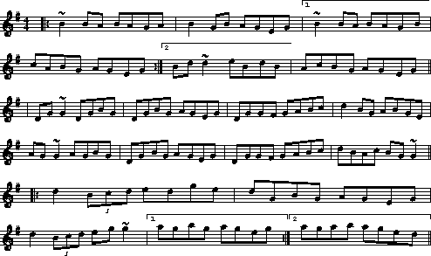

Jerry Beaver's Hat (Jig)

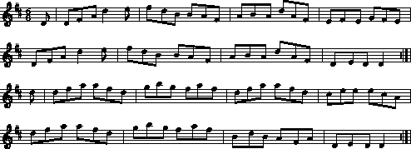

Jill Morrison of  Haircrafters  747 Farmington Avenue  Kensington, CT  (860) 830-2699 | Calley McGrane& the Exiles  Live Celtic Music  John McGrane, Mgr. jmcgrane@comcast.net  (860) 676-1379  www.calleymcgrane.com | To advertise here contact  Curry-Seery CCE

To advertise here or to obtain rate information call Terry Sullivan at (860) 584-8776 or via email at curry-seery-cce@hotmail.com.

From: Burke-Curry-Seery Branch, CCE
c/o Liz Raymond, Secretary
484 Round Hill Road, Middletown, CT 06457

To:

