
COMHALTAS CEOLTÓIRI ÉIREANN
Burke-Curry-Seery Branch

From the Chairman,

As one year comes to a close, another year begins. With that, I ask that you review the date on the address label on this newsletter. This date is your membership expiration date. In order to avoid a lapse in membership, please complete the enclosed membership application and send it in with payment as soon as possible.

As my term as your Branch Chairman comes to an end (October 31st), I want to reflect briefly on what your Board has accomplished this past year.

1. Communication. We mailed out a total of 6 newsletters this year to meet the Board's goal of increased communication. Our website continues to be updated for current information and contains links to previous newsletters.

2. Advertisements. We started a successful newsletter advertisement campaign to help defray the costs of mailing newsletters to each member (see last page). Please support them!

3. Concerts. The February 24, 2006 P.V. O'Donnell and Michael Cooney concert was a near sellout. We are confident the October 13th Echoes of Erin concert in Hamden will be well attended. Bringing these concerts to the area is a lot of work, but essential in supporting and promoting Irish cultural activities.

4. Membership. Branch membership grew by more than 135% in the last year.

5. Irish History Program. We put on two Irish History lectures in March and April that were well attended.

6. Irish Language Instruction. We started a beginners' Irish language program in Glastonbury and from the moment it was announced in January, we had over 45 responses. A second beginner's class started last month and we will have two classes starting in January 2007! A special thanks goes out to Joe Rice who made it all happen and to the Glastonbury Irish American Home Society and Eileen McGee who made the space available.

Our next Branch meeting is October 29, 2006 in Glastonbury, CT, which is our annual general meeting. Among other business, elections of Branch officers will occur. If you, or somebody you know, are interested in serving as a Branch officer, contact a member of the Nominating Committee (see page 2)

Please read on for important information pertaining to planned Comhaltas activities. As always, your input is most welcome. If it's time to renew your membership, an application is enclosed for your use.

Thank you for having me as your Chairman. It has been a busy and productive year. My wish is that the next Board has continued success so that the Branch can grow and thrive. Go raibh maith agat!

Terry Sullivan, Cathaoirleach (Chairman)

Next Branch Meeting - October 29th

The next meeting of the Burke-Curry-Seery Branch of CCE will be held at 2:00 p.m. on Sunday, October 29, 2006 at the Irish American Home Society, Commerce Street, Glastonbury, CT. This is the Branch's annual general meeting at which elections of Branch officers occur. A review of recent Branch activities and future plans will be discussed. This is a great opportunity to become involved in your Branch. Please make every effort to attend.

Echoes of Erin Concert - October 13, 2006

The Burke-Curry-Seery Branch of CCE is sponsoring the 2006 Echoes of Erin Concert on Friday, October 13, 2006 at Hamden High School at 7:30 p.m. This show features talented singers, dancers and musicians from Ireland who are performing in the United States this fall. Tickets cost only $20 for adults and $10 for children age 14 and under. We are hoping to sell as many advance tickets as possible so contact us soon to obtain yours. Please attend and show support for your Comhatas branch which is promoting this concert.

We are asking for volunteers to host some of the performers (mostly young adults) which mean transporting them from the post-concert get-together Friday October 13th at the IACC in New Haven to their homes for the night and then to the bus (probably in North Haven) in the morning for their trip to the next concert venue.

If you have any questions, please call Terry Sullivan at (860) 584-8776, John O'Donovan at (203) 281-3563 or Jill Morrison at (860) 830-2699.

Nominations for CCE Officers

The "year" for the present Branch Board members expires on October 31, 2006. If you are interested in serving on the Board for a one-year term, please submit your name to the nominating committee. The nominating committee consists of Greg Gregonis (860-763-6754 or email grouse01@cox.net), Eileen Grabowski (860-529-2922), and Terry Sullivan (860-584-8776 or email terrysullivan-1@hotmail.com). If you have particular questions about the duties and time commitments involved, please feel free to contact any of the present Board members. The election of officers will take place at the annual general meeting on October 29th in Glastonbury (see above).

The following positions will be up for election:

Chairman, Vice Chairman, Secretary, Treasurer, Public Relations Officer, Chaplain, Irish Language Officer, Auditor and two Delegates to the Regional Meeting.

Connecticut Irish-American Historical Society

The Connecticut Irish American Historical Society is seeking members interested in learning more about the Irish in Connecticut. The Society conducts research, catalogs records, maintains a website, sponsors lectures and organizes bus tours to places of Irish interest. It produces a wonderful newsletter, The Shanachie, on a quarterly basis and provides regular e-mail updates to members that describe upcoming activities and projects. A membership application is included in this newsletter. Please give it some thought. Questions should be directed to Neil Hogan, at the Society (see the enclosed application for the address).

Northeast Regional Meeting to Be Held November 4th in Albany, NY

The 2006 Northeast Regional Meeting will be held in the Albany, NY area on Saturday November 4, 2006. The meeting will be held once again at the American Legion Hall in Delmar, a suburb of Albany.
After the business meeting of Regional and Branch officers, a banquet dinner is held during which CCE members elected to the Regional Hall of Fame are honored. Each "Hall of Famer" generally performs a few numbers for the audiences listening pleasure and the festivities are followed by a mighty seisiun. Dancers have been known to take to the floor making this one very festive evening. We are proud to announce again that Branch members Jim Smith and John Tabb will be inducted into the Regional Hall of Fame. Congratulations Jim and John - a well-deserved honor! Details of this event will be available on our Branch website in the very near future. If you have any questions in the meanwhile, please contact Terry Sullivan at (860) 584-8776 or email the Branch at curry-seery-cce@hotmail.com.

Last month we provided you with sheet music for a couple of tunes. Here are two more. Enjoy!

Harp and the Shamrock (hornpipe)

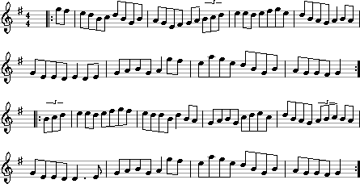

Tomgraney Castle (hornpipe)

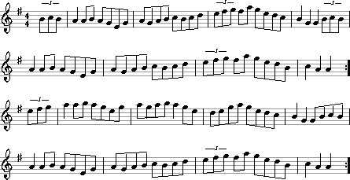

Jill Morrison of  Haircrafters  747 Farmington Avenue  Kensington, CT  (860) 830-2699 | Calley McGrane& the Exiles  Live Celtic Music  John McGrane, Mgr. jhmcgrane@comcast.net  (860) 676-1379  www.calleymcgrane.com | Eleanor Nettleton, LMT  Family Massage Therapy  East Hampton CT Office  Home Visits /  Sliding Scale  (860) 267-6587

From: Burke-Curry-Seery Branch, CCE
c/o Liz Raymond, Secretary
484 Round Hill Road, Middletown, CT 06457

To:

