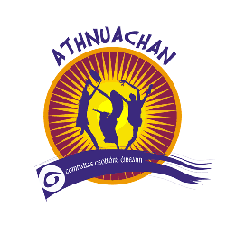
COMHALTAS CEOLTÓIRI ÉIREANN
Burke-Curry-Seery Branch

From the Vice - Chairman,

Greetings to all! Happy Holidays to each of you.

Please make sure your membership does not lapse. Review the expiration date of your membership on the mailing label of this newsletter. In order to avoid a lapse in membership, please complete the enclosed membership application and send it in with payment as soon as possible.

On October 21, we held our annual membership meeting and elections of new Branch Officers.

I would like to congratulate the new officers that were elected. Stuart McEnerney – Vice Chairman, Cynthia Prior – Secretary, Eileen Grabowski – Treasurer, Neil Hogan - Public Relations, John Feeney – Irish Language Officer, John O’Donovan – Chaplain, Mary Burke and Steve Mahoney - Delegates. I hope that all members will welcome and help this new administration keep the achievements of the branch moving forward.

All ideas and input are welcome, after all this is your branch.

If you noticed this newsletter is from our Vice- Chairman, at the annual meeting, we failed to fill two positions on the board. If you are interested in running for Chairman or Auditor, please let us know.

I would like to extend a heart felt Thank you to the outgoing board members for a job well done and setting the bar so high for the next administration. I want to thank Terry Sullivan, Jill Morrison, and Liz Raymond for their hard work and dedication to the branch over the past two years.

Finally, our Branch email has changed (see below).

Stuart McEnerney, Leaschathaoirleach (Vice -Chairman)

CEILI DANCE BIG SUCCESS IN MERIDEN, CT

The Meriden Ancient Order of Hibernians co-sponsored beginner ceili dance for both children and adults at the AOH hall located at 71 Melville Avenue, Meriden, CT this past fall. The dancing will continue again in the spring, keep an eye out for further information in future newsletters to join in the fun.

MID ATLANTIC HALL OF FAME

Mid-Atlantic Region Annual Hall of Fame Céilí 2008 Honorees: Brendan Mulvihill and Larry Redican (RIP) Saturday, February 16th

7:00 pm to midnight at Irish American Society of Nassau, Suffolk, and Queens 297 Willis Avenue
Mineola, NY for further information:

www.ccenorthamerica.org/Sites/MidAtlHallOfFame For directions: www.irishamericansoc.com

2008 CCE NORTH AMERICAN CONVENTION

The CCE North American Convention will be held on March 27 – 30, 2008 in Parsippany, NJ. A brochure was inserted in the latest edition of Treior magazine. The CCE room rate is $119 and filling up quickly. Please see their website www.cceconvention2008.org for further information.

IRISH SET DANCING AT THE IRISH AMERICAN HOME SOCIETY,
GLASTONBURY, CT

Set dancing schedule for 2008 at the Irish American
Home Society is as follows:

January 2, 9, 16, 30 February 6, 13, 20 March 5, 12, 19 April 2, 9, 16, 30 May 7, 14, 21 June 4, 11, 18

July 2, 9, 16, 30 August 6, 13, 20 September 3, 10, 1 October 1, 8, 15, 29
November 5, 12, 19 December 3, 10, 16

IRISH LANGUAGE

Starting in January on the 3rd Sunday of the month at the Irish American Home Society in
Glastonbury, CT (before the seisiún – from 1:30 – 3) there will be a beginner’s Irish language practice seisiún.
This is not to teach the language but rather to practice speaking; we are encouraging those fluent in Irish (with
a lot of patience!!) to come help those of you just beginning to improve our speaking & comprehension skills.

IRISH LANGUAGE LESSONS

Language lessons will be continuing for Beginners and Advanced Beginners at the Irish American Home Society in Glastonbury, CT. Classes will be resuming in January and will be meeting on Tuesday evenings at 7 pm and 9 pm respectively. Classes are $45.00. If interested in learning or continuing the language please contact Johanna Mackey via email at Johannah@snet.net for further information.

LANGUAGE TEACHER

If anyone knows of someone who would like to teach a beginner Irish language class at the Gaelic American Club in Fairfield, CT please let our Irish Language Officer John Feeney know, he can be reached at johnfeeney51@comcast.net

The Irish Language (An Ghaeilge)
In the May 2007 newsletter, I wrote about pronunciation of vowels both accented and unaccented. This time I will describe some other features of Irish that are important in terms of pronunciation. Irish has two other features, which affect the way you say consonants. One involves the use of the letter “h” after a consonant and the other is the combination of two consonants.

BH, MH, and BHF pronounced as a V or W.
DH and GH pronounced as a G or Y sound.
FH not pronounced. Totally silent.
CH pronounced as a guttural (back of the throat) CH.
SH and TH pronounced as an H. The S and T are silent.
PH pronounced as an F.

Examples: mo bhád (pronounced muh wawd) my boat; mo dhán (muh gawn) my poem; an fhuinneog (un winyeog) the window; mo phíopa (muh feeopa) my pipe; and an bhfuil tú (un will too) are you? This is why the name Siobhán is pronounced with a V sound.

The other feature is the combination of two consonants at the beginning of a word. For example: gc, mb, nd, bp, etc. These pairs of consonants look unpronounceable and they are. When you see them, you only pronounce the first consonant. Examples: i nDanbury (ih nanbury) in Danbury or ar an mbórd (air an mawd) on the table.
Nollaig Shona Daoibh (Nuhlug huna deev)
Merry Christmas to you all!

John

There will be an Irish Language day at the end of March to be held at Iona College. More information will be in the next newsletter.

IRISH AMERICAN COMMUNITY CENTER OF EAST HAVEN, CT PRESENTS
2008 TRADITIONAL IRISH MUSICCONCERT

Come celebrate “Little Christmas Eve” by attending a concert that features four of the all time great Irish musicians Joanie Madden, Brian Conway, Brendan Dolan, and Billy McComiskey in concert at the IACC East Haven on Sat. 5th Jan. at 7:30 pm. Joanie Madden, flute and whistle player, leader of Cherish the Ladies will be joined by Brian Conway, fiddler, from Co. Sligo who has won numerous All Ireland Fiddle competitions, Brendan Dolan, keyboard and flute, who scores music for cable TV including MTV and The Discovery Channel, and Billy McComiskey, accordion, a native of Brooklyn who won the All Ireland Senior Title in 1986. Billy is highly regarded for playing and composing. This concert should not be missed. Tickets: $15 in advance, $20 at the door. For information and directions call Pat Stratton 248-8396 or John O’Donovan 281-3563.

BRANCH MEMBERSHIP MEETING ON JANUARY 26, 2008

The next meeting of our Branch will be held at 3:00 p.m. on Saturday, January 26th at The Meriden Ancient Order of Hibernians 71 Melville Ave, Meriden, CT. Come meet your new and old branch officers and share your ideas, we want to hear from you. We will be discussing the North American Convention to be held in March, upcoming events, attracting volunteers, increasing membership, and discussing the open officers’ positions. Immediately following the meeting will be a seisiún from 5:30 p.m. to 8:30 p.m., a small meal will be provided for those who attend the meeting. For directions, call (203) 235-6269 or visit map quest at www.mapquest.com.

MEMBER NOTES

Congratulations go out to Shannon McEnerney, daughter of Vice Chairman Stuart McEnerney, for placing first and second place in her very first step dancing Feis held December 8, 2007.

We also congratulate Stuart McEnerney for successfully completing his Masters degree in Elementary Education and wish him luck.
If any member has note worthy information they would like to have put in a newsletter, please email BurkeCurrySeery@comhaltas.net

EMAIL

Our Branch email had changed to BurkeCurrySeery@comhaltas.net. Please make a note of it.
If you have an email address please let our Branch secretary know at cjpriority@cox.net. We are able to update our members more quickly if we have your email address. Also, if you would like to receive the newsletter by email instead of by regular mail please let us know. This will also help reduce the cost of mailings and get the information to you quicker.

VOLUNTEERS NEEDED

We are in need of Volunteers for regular branch functions. This is a great way to get involved with Comhaltas and your Branch. Meet interesting people, listen to good music, and have fun spreading the Irish Culture. Some of the responsibilities are working at Festivals, selling tickets for concerts, and handling raffles. If you can donate a few hours to your Branch, please contact a Branch officer or email us at BurkeCurrySeery@comhaltas.net

ADVERTISEMENTS

If you would like to have your business or service advertised in our newsletter for a reasonable cost, please contact Stuart McEnerney via email stumcenerney@sbcglobal.net for further information. This is a great way to get your business flourishing as these newsletters are also posted on the internet via our website www.blarneystone.com/comhaltas

DANBURY SEISIUN

Danbury, CT AOH hosts a traditional music seisiún on the last Sunday of the month at 6-9 PM year round. The seisiún has been drawing many musicians from Westchester, NY as well as Western and Central CT and has been going since April 07. The Danbury AOH has purchased a new property and plans to open the Greater Danbury Irish Cultural Center around April 2008. For more information and directions, see their website at www.danburyhibernians.org

AREA MUSIC EVENTS

Here are some shows coming to the area that you may find interesting.

Martin Hayes and Denis Cahill will be performing on January 13, 2008 and Lunasa February 29, 2008 at the intimate Fairfield Theatre Company Fairfield, CT. For more information, see their website at www.fairfieldtheatre.org

Old Blind Dogs will be performing at the University of Hartford February 9, 2008 at the Wilde Auditorium. For further information, see their website at www.harttweb.hartford.edu

Cherish the Ladies will be performing in the Cromwell Concert Hall at Wesleyan University, Middletown, CT March 1, 2008. For more information see their website at www.wesleyan.edu/cfa/events

Grada will be performing at the East Hartford Community Cultural Center in East Haven, CT March 14, 2008. For more information, see their website at www.ehccc.com

Remember to join us at our area seisiúns held in several venues around the state of CT.

Sunday – Glastonbury first and third Sunday starts at 4 pm- 6 pm; New Britain AOH second and fourth Sunday starting at 4 pm – 6pm, Danbury AOH last Sunday starts at 6 pm – 9pm; and every Sunday at the Hamden Playwright Restaurant starting at 3 pm – 5pm.

Tuesday-Playwright, Hamden starting at 8 pm Wednesday – City Steam, Hartford starting at 7:30 pm

Thursday – Old Dublin, Wallingford starting at 7:30 pm

PLEASE SUPPORT OUR ADVERTISERS THAT HAVE GENEROUSLY SUPPORTED OUR NEWSLETTERS. WITHOUT THEM, OUR MAILINGS COULD NOT TAKE PLACE AS OFTEN AS THEY DO.

Here is a great jig:

The Irish Girl

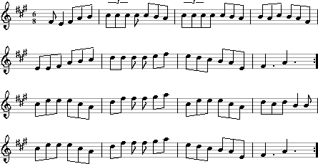

SAINT PATRICK’S DAY

There are some exciting events being planned for the Saint Patrick’s Day weekend in Hartford. Some of the events being planned are a reception at the governor’s mansion, a parade, a Sunday brunch at an area restaurant, music, dancing, and just some plain old fun!!! Look for more information in the next newsletter and come to our Branch meeting to find out more details for what is planned.

Our next Newsletter will have information on all the area Saint Patrick’s Day Festivities that are being planned throughout the state.

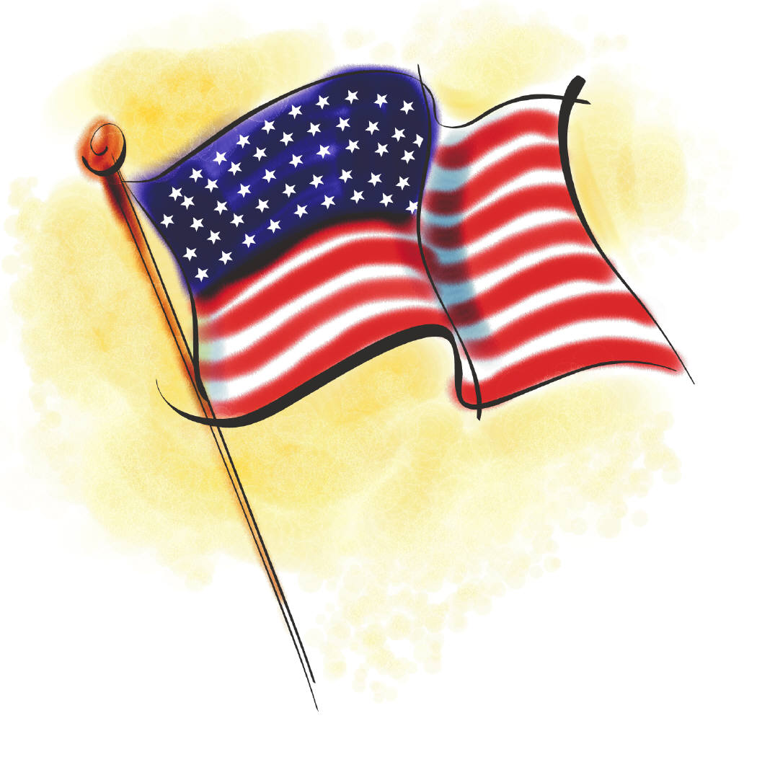  Hall Rentals  Meriden Ancient Order of  Hibernians  71 Melville Avenue Meriden, CT  203-686-0079  Are you looking for the perfect place to hold that special gathering, lecture, or concert at an affordable price? Call for more information. |  |  | Eleanor Nettleton, LMT  Family Massage Therapy  East Hampton, CT Office  Home Visits Available  Sliding Scale  (860) 267-6587  Gift Certificates Available  Portable Table Will Travel
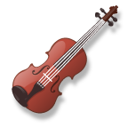  Calley McGrane& the Exiles  Live Celtic Music  John McGrane, Mgr. jhmcgrane@comcast.net  (860) 676-1379  www.calleymcgrane.com | _________________________________


From: Burke-Curry-Seery Branch, CCE
C/o Cynthia Prior, Secretary
P.O. Box 230703, Hartford, CT 06123-0703

To:

